Claremont Bank Surgery Newsletter January 2020
Join the four million going dry this January
- Reset your drinking
- Save money
- Have more energy
- Feel great
To sign up for Dry January visit - Dryjanuary.org.uk
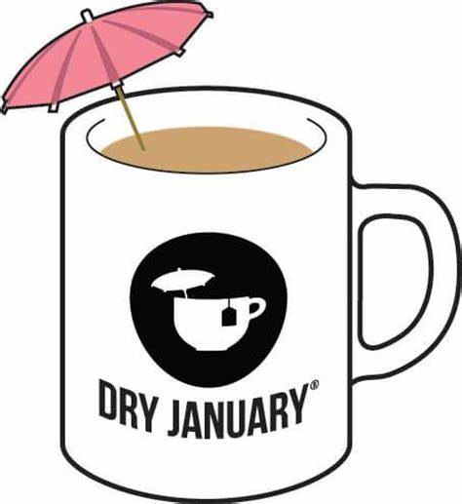

Dry January is the annual movement through which millions of people give up alcohol for the month of January. It is run by the charity Alcohol Change UK. Dry January is the perfect way to reset your relationship with alcohol. It only takes 3 weeks to break a habit, so this could be your route to happier, healthier drinking long-term. Plus these benefits:
- Sleep better and have more energy
- Better skin
- Lose weight
- More money in your pocket (the average person spends £50,000 on booze in their lifetime)
- Get healthier- through giving up alcohol for a month you do your insides a lot of good
- Amazing sense of achievement!

Download the Dry January App.
If you are eligible for a Flu Jab and have not had one please book in. Phone 01743 248244 and speak to a receptionist.
ARE YOU ASTHMATIC?
If you are asthmatic and have not had an asthma review with the Practice Nurse in the last 12 months then please book an appointment.

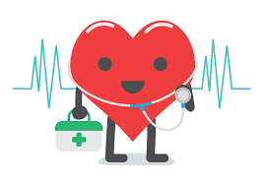

Darwin Extended Hours
Claremont Bank Surgery has appointments available on Monday evenings between 6pm-8pm with doctors and nurses. We can also offer appointments on evenings and weekends at other surgeries. To book one of these appointments please call 01743 248244 and speak to a receptionist.

If you are between the ages of 40 and 74 please contact the surgery on 01743 248244 to see you if you eligible for an NHS Health Check with Anne-Marie Stokes. The check should take about 30 minutes and is based on straight forward questions and measurements such as age, sex, family history, height, weight and blood pressure. There will also be simple blood tests to measure your cholesterol and if required glucose levels.

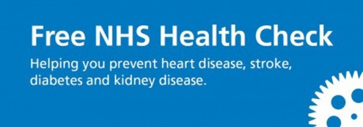
Claremont Bank Surgery Boundary Area
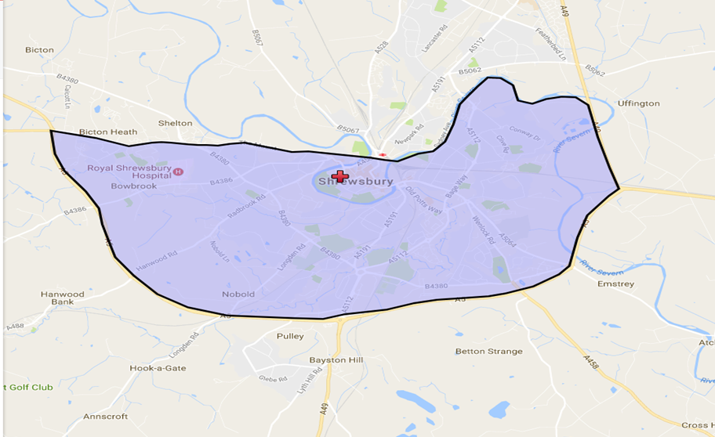

In the past we had not strictly enforced our practice boundary but more recently we are seeing a significant rise in patients who want to register at Claremont Bank Surgery. This may be due to new housing development and the recent closure of Whitehall Medical Practice. We are obliged to accept patients who ask to join who live within our boundary and as a consequence our list size numbers are rising. All of the Doctors at Claremont Bank Surgery are concerned that if our list size rises we will be unable to continue to offer the high standard of care that our patients have come to expect. As a result we are starting to decline to accept patients who have now moved outside of our boundary.
E consult
Claremont Bank Surgery will be using E Consult from the 7th January. E Consult lets patients consult with their own NHS GP online by completing a quick form that is sent and reviewed by the practice.
E Consult is free to use for NHS patients. You can use E Consult to ask your GP surgery about your health symptoms, conditions or treatment. You can even request things like sick notes.
- Find your symptom, condition or request.
- Fill out a quick form.
- Your practice responds by phone or email.
the History of e consult
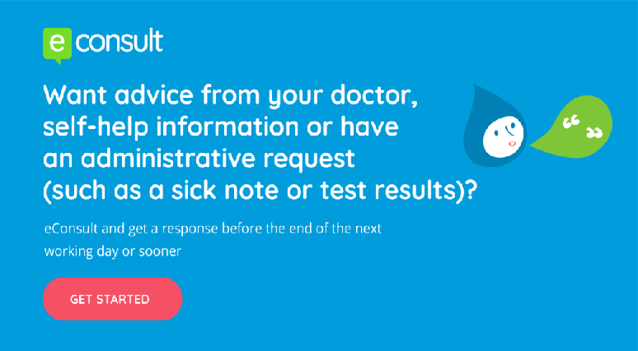
In 2014, four innovative GP Partners at the Hurley Group in South East London pioneered the delivery of the first online consultation. They wanted technology to help them work smarter, and quickly grew to become the NHS’s leading online consultation provider. Since 2017 they have been developing a future blueprint for the delivery healthcare through a digital-first mode.

